Effect of Gain on Settling Time in Open-Loop and Closed Loop System

Name

Institution

ME 4160 Controls Lab 3

“Effect of Gain on Settling Time in Open-Loop and Closed-Loop System”

Abstract:
The aim of this experiment is familiarize the concept control system. That is the open and closed loop system. Then observe and compare the effect of the gain has on settling time in each type of systems.

Introduction:

Open loop system: in this case, the output has no effect on the control action of the input signal. Its major characteristic include the fact that the output condition is not measured or fed back for comparison with the input signal. Some of the examples of open loop system include washing machines, light switches and gas oven.

Closed loop system: This system involves a set of mechanical or electronic devices that automatically regulate a certain process variable to the required state. This system can also be used to set a point without human interaction. The two types of control system contrast with each other which explains the need for manual input.

- An open loop control system performs completely based on input and the output bears no single effect on the control action.
- A closed loop control system pays attention to the current output and then transforms it to the desired condition.
- Closed loop control systems mainly focus on stability of the system as the main issue.

Procedure:
1-a Open-loop System

- Connect the wires for an open-loop system as shown in Figure 1.

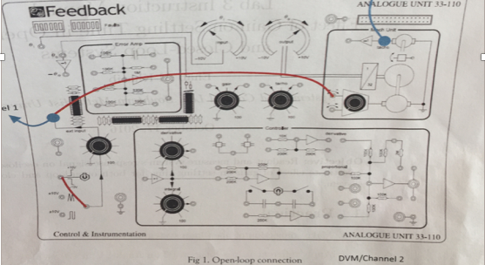
Figure 1: Open Loop Connection

- Apply different values of gain p3 on analog unit (20%, 40%, 80%, 100) and +10V unit input voltage. Then measure steady state voltage and motor RPM using DVM port.

- Then took measurements by looking at the oscilloscope and the volt and rpm outputs from the mechanical unit. After this, plot the response of the motor’s steady-state output voltage with respect to different gain values, for both system as well in the same plots.

1-b Closed -loop system

- Connect the wires for a closed-loop system as shown in Figure 2.

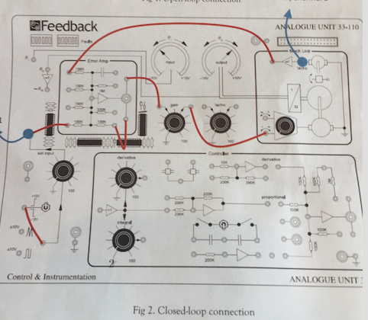
Figure 2: Connections for Closed Loop

- For closed-loop system repeat the same above system but for system set P3= 100% and P1 at different Values (20% 40% 80% 100%).

- Then take measurements by looking at the oscilloscope and the volt and rpm outputs from the mechanical unit. After this, plot the response of the motor’s steady-state output voltage with respect to different gain values, for both system as well in the same plots.

Experimental Data:
Table 1: Open Loop System
Gain = P3/P1
- For 20% Gain

%Vfinal | Time[ms] | V_{out}[V]
10% | 140 | 0.13
50% | 340 | 0.05
90% | 1.47 | 1.17
100% | 1.86 | 1.30
settling | 1.81 | 1.274

- For 40% Gain

%Vfinal | Time[ms] | V_{out}[V]
10% | 60 | 0.33
50% | 320 | 1.67
90% | 1.005 | 3.01
100% | 1.75 | 3.34
settling | 1.705 | 3.27

- For 80% Gain

%Vfinal | Time[ms] | V_{out}[V]
10% | 60 | 0.723
50% | 340 us | 3.62
90% | 1.005 | 6.51
100% | 1.76 | 7.23
settling | 1.72 | 7.08

- For 100% Gain

%Vfinal | Time[ms] | V_{out}[V]
10% | 100 | 0.73
50% | 280 | 3.65
90% | 660 | 6.57
100% | 1.37 | 7.30
settling | 1.2 | 7.15
Experimental Data:
Table 2: Closed-Loop SystemGain = P3/P1
- For 20% Gain

%Vfinal | Time[ms] | V_{out}[V]
10% | 140 | 0.046
50% | 360 | 0.23
90% | 1.10 | 0.414
100% | 1.42 | 3.34
settling | 1.215 | 0.45

- For 40% Gain

%Vfinal | Time[ms] | V_{out}[V]
10% | 80 | 0.117
50% | 280 | 0.585
90% | 720 | 1.053
100% | 1.12 | 1.17
settling

- For 80% Gain

%Vfinal | Time[ms] | V_{out}[V]
10% | 40 | 0.36
50% | 220 | 1.34
90% | 620 | 3.32
100% | 660 | 3.64
settling | 8.42 | 3.55

- For 100% Gain

%Vfinal | Time[ms] | V_{out}[V]
10% | 40 | 0.47
50% | 180 | 2.38
90% | 520 | 4.293
100% | 800 | 4.77
settling | 784 | 4.67

Calculation:
For 20%
$$0.0462V×11.428=0.52 rpm$$
For 40%
$$0.117V×11.428\frac{rpm}{V}=1.337 rpm$$
For 80%
$$0.36V×11.428\frac{rpm}{V}=4.15405 rpm$$
For 100%
$$0.4732V×11.428\frac{rpm}{V}=5.37369 rpm$$
Results:
After the experiment is done, the effect of gain on the settling time for open and closed loop system is obtained. To plot the response we make use of 5 data points (10%, 50%, 90%, 100%, settling time) for each response curve and convert the motor to rpm.
To convert the voltage output from volts to RPM, we use the K value from our Lab 1 and the following equation:

$$ω=KV_{out}$$

The K value used for lab3 is 11.428 rpm/V.
- In Graph 1 I have shown the relationship between the motor response and the percent of the steady state for the open loop for each of the P3 gain positions.

Graph 1. Open Loop motor response (RPM)

- In Graph-2 I have shown the relationship between the motor response and the percent of the steady state for the closed loop for each of the P3 gain positions.

Graph 2. Closed Loop motor response (RPM)

- In Graph-3 I have shown the difference between open loop and closed loop for gain as it affects the settling time.

Graph 3. Open vs Closed loop gain effects on settling time 10%

- Graph 4 shows the difference between open loop and closed loop for gain as it affects the settling time.
Graph 4. Open vs Closed loop gain effects on settling time 50%

Graph 5 shows the difference between open loop and closed loop for gain as it affects the settling time.

Graph 5. Open vs Closed loop gain effects on settling time 90%

- Graph 6 shows the difference between open loop and closed loop for gain as it affects the settling time.

Graph 6. Open vs Closed loop gain effects on settling time 100%
.

- Graph 7 shows the difference between open loop and closed loop for gain as it affects the settling time.
Graph 7. Open vs Closed loop gain effects on settling time 98%

Discussion and Analysis:

As we can see from the above graph, open loop’s graph (3,4,5,6,7) showed a more different settling time because open loop has no feedback. In contrast, closed loop has a more constant settling time because it has feedback. While both systems have varying settling times, the closed loop has the more constant settling time, as expected. By viewing graphs, we can say that as the gain increases the correlation with settling time is not expressed as purely positive or negative. However, for the closed loop system, as the gain increases, the settling time seems to either remain constant or gradually decrease.

Conclusion:

At the end of this experiment, I obtained the knowledge on effect of gain on the settling in time open and closed loop

